Contents

**1.** **Lab introduction:** 2

**2.** **Q&&A** 3

**3.** **GNSS positioning and analysis using u-blox receiver** 3

**3.1 U-blox receiver** 3

**3.2 Data Collection with u-blox Receiver** 4

**3.2.1 Installation and Hardware Setup** 4

**3.2.2 Using u-center for GNSS Data Collection** 4

**3.3 Data analysis with RTKLIB** 6

**3.3.1 Raw Data Format Conversion** 6

**3.3.3 Ephmeris** 7

**3.3.4 Configure Processing Options** 10

**3.3.5 View and Analyze Results** 11

**3.3.6 Display results in Google Earth** 11

**4.** **GNSS positioning and analysis using a smartphone receiver** 13

**4.1 Smartphone receiver** 13

**4.2 Data collection with smartphone receiver** 13

**4.2.1 Collect data** 13

**4.2.2 Get the data from the smartphone** 14

**4.3 Data analysis with Sing positioning** 14

**4.3.1 Download the navigation file in the Geodetic Survey of Hong Kong.** 14

**4.3.2 Obtain the ionospheric, tropospheric, pseudoranges, satellite clock bias and satellite positions.** 17

**4.3.3 Use the python program of least square method to deal with the data, and get the position.** 18

**GNSS Navigation Lab (AAE4203-Guidance and Navigation)**

# **Lab introduction:**

Global Navigation Satellite Systems (GNSS) is a cornerstone of modern positioning, navigation, and timing (PNT) technologies. They provide accurate location and time information to users anywhere on Earth, under any weather conditions, and at any time. GNSS positioning has revolutionized many aspects of modern life, providing critical data for navigation, timing, and location-based services. As technology continues to advance, GNSS will become even more integral to our daily activities and various industries.

The GNSS navigation lab focuses on the data collection of the GNSS receiver and its data processing using Python programming. The student is expected to learn to use the GNSS receiver to collect the data and process the GNSS data, such as the GNSS single-point positioning. The expected learning outcome of this lab is as follows:

* *Objective 1*: Learn to use the usage of the GNSS data collection software, such as the u-center for the u-blox receiver data collection, and the GNSS Logger for GNSS data collection from the Android smartphone.
* *Objective 2*: GNSS data processing using the RTKLIB, including the position and velocity estimation.
* *Objective 3*: GNSS data processing using Python programming, including position and velocity estimation.
* *Objective 4*: Learn the analysis of the data, such as the positioning error evaluation using a static dataset. All these should be done using the Python code.
* *Objective 5*: Students are required to submit a 2-page report on the lab. The lab should include the following components: (1) GNSS positioning results and visualization (e.g. with RTKLIB), (2) evaluation of the static dataset collected in urban areas. (3) learning experiences in this lab.

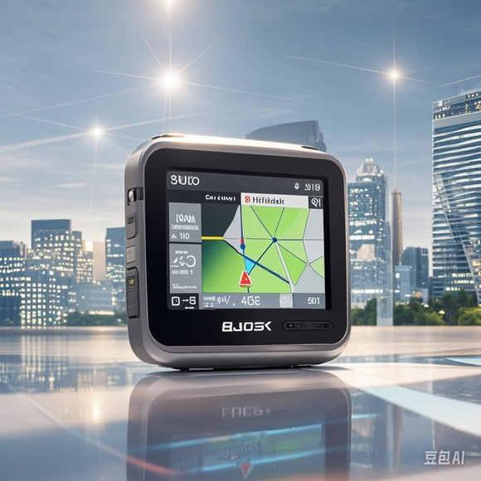

Fig 1: (Left) Smartphone-based GNSS positioning in urban canyons. (Right) GNSS receiver-based positioning in urban canyons.

Fig 2: Overview of the lab. Two sets of GNSS receivers could be used for the data collection.

# **Q&&A**

* **Lecturer**: [Dr. Weisong Wen](https://www.polyu.edu.hk/aae/people/academic-staff/dr-wen-weisong/), [Department of Aeronautical and Aviation Engineering](https://www.polyu.edu.hk/aae/) (AAE)
* **Address**: PQ408, PolyU.
* **Email**: [welson.wen@polyu.edu.hk](mailto:welson.wen@polyu.edu.hk)
* **Teaching Assistant**: Ruijie Xu, Xikun Liu, Yuan Li, Yihan Zhong.
* **Lecture Venue and Time**: BC303, Thu 15:30-18:20
* **Github issue**: <https://github.com/weisongwen/AAE4203-2425S1/issues>

1. **GNSS positioning and analysis using u-blox receiver**

**3.1 U-blox receiver**

u-blox provides commercial-grade GNSS receivers that support multi-constellation and multi-band signals for precise positioning.

|  |
| --- |
|  |
| Fig 3: Illustration of the u-blox GNSS receiver kit. |

* Multi-band GNSS Receiver: Supports concurrent reception of multiple GNSS constellations (GPS, GLONASS, Galileo, BeiDou).
* Concurrent Multi-Constellation Reception: Receives signals from various constellations simultaneously, improving accuracy and reliability.
* Small and Power-Efficient: The ZED-F9P module is compact and energy-efficient, making it suitable for integration into a variety of devices.

**3.2 Data Collection with u-blox Receiver**

**3.2.1 Installation and Hardware Setup**

Connect the antenna, receiver and computer as shown in Figure 4 (F9P) and Figure 5 (F10T).

|  |
| --- |
|  |
| Fig 4: Illustration of the u-blox GNSS receiver F9P kit connection with the antenna. |
|  |
| Fig 5: Illustration of the u-blox GNSS receiver F10T kit connection with the antenna. |

**3.2.2 Using u-center for GNSS Data Collection**

u-blox provides u-center, a powerful evaluation software tool designed to configure, monitor, and analyze GNSS data. Follow these steps to collect data with u-center:

**Step 1:** Download and Install u-center:

<https://www.u-blox.com/en/product/u-center>.

**Step 2:** Open u-center, select connection and choose the correct COM port and set the baud rate(typically 9600 or 115200) to establish proper communication.

|  |
| --- |
|  |
| Fig 6: Illustration of the u-center software in the computer: connect receiver. |

**Step 3:** Once the receiver is connected, the u-center will begin displaying real-time data from multiple GNSS constellations, including satellite count, signal strength, and positional coordinates. The Satellite View screen allows you to visualize the status of each satellite being received.

|  |
| --- |
|  |
| Fig 7: Illustration of the u-center software in the computer with satellite visualization. |

**Step 4:** Click "record" in the menu bar to start recording, and then select a path to save the data file.

|  |
| --- |
| **C:/Users/Lenovo/Desktop/图片1.png图片1** |
| Fig 8: Illustration of the u-center software in the compute: start recording. |

**Step 5:** The hardware and software are ready, let's start collecting data!

**Step 6:** After the collection is completed, click "Eject File" in the menu bar.

|  |
| --- |
|  |
| Fig 9: Illustration of the u-center software in the compute: stop recording. |

**3.3 Data analysis with RTKLIB**

RTKLIB is an open-source software library for GNSS data processing, supporting Real-Time Kinematic (RTK) and post-processing modes.

**Step 1:** Download and install RTKLIB

[rtklib_download](https://www.dropbox.com/scl/fo/32trvbm868h038lfwg9mg/AFLja6jU3qK55FRuiUoto_c?rlkey=lg1gzafo58xcktltzm7fpg118&dl=0)

**Step 2:** Open “rtklauch.exe”.

|  |
| --- |
|  |
| Fig 10: Illustration of the rtklauch in the compute. |

**3.3.1 Raw Data Format Conversion**

**Step 3:** Open “RTKCONV” and then convert raw data (ubx file saved by u-center) to RINEX format.

* Do not check “Time Start(GPST)”, “Time End(GPST)” and “Interval”.
* “RTCM, RCV or RINEX OBS”: the raw data file saved by U-center
* Format: choose UBX
* Make sure the “.obs” file and “.nav” file are checked. These are output files.

|  |
| --- |
|  |
| Fig 11: Illustration of the rtkconv software in the compute: convert .ubx to RINEX. |

**3.3.3 Ephmeris**

**Step 4:** Go to the ephemeris website

<https://www.geodetic.gov.hk/tc/rinex/downv.aspx>

**Step 5:** Please select step 1 and step 2 according to the following example.

|  |
| --- |
|  |
| Fig 12: Illustration of step1 and step 2 of downloading ephemeris. |

**Step 6:** Open the “.obs” output file in step 3 and note the start and end time.

* The time period in the figures is 25/09/2024 7 hour 25 minute – 25/09/2024 7 hour 28 minute.

|  |
| --- |
|  |
| Fig 13: Illustration of the start time. |
|  |
|  |
| Fig 14: Illustration of the end time. |

**Step 7:** Select the corresponding time period on the website and submit.

*Noted that time in the file is not HKT (UTC= HKT – 8)

|  |
| --- |
|  |
| Fig 15: Illustration of step3 and step 4 of downloading ephemeris. |

**Step 8:** Download the ephemeris file.

|  |
| --- |
|  |
| Fig 16: Illustration of web download of SatRef GNSS Raw Data. |

**Step 9:** Extract the ZIP file and then follow the steps in the figure below.

|  |
| --- |
|  |
| Fig 17: Illustration of how to get output folder. |
|  |
| Fig 18: Illustration of ephemeris. |

**3.3.4 Configure Processing Options**

**Step 10:** Open “RTKpost” through rtklauch and select the corresponding files.

* RINEX OBS Rover: the output .obs file in step 3 (rtkconv)
* RINEX OBS Base Station: “.24o” file in step 9.
* RINEXNAV/CLK: the output .nav file in step 3 (rtkconv)

|  |
| --- |
|  |
| Fig 19: Illustration of the usage of rtkpost. |

**3.3.5 View and Analyze Results**

**Step 11:** Click “plot”.

|  |
| --- |
|  |
| |  | | --- | | Fig 20: Illustration of plot button in rtkpost. | |
|  |
| Fig 21: Illustration of the ground track. |

**3.3.6 Display results in Google Earth**

**Step 1:** convert the output file from POS to KML

|  |
| --- |
|  |
| Fig 22: Illustration of rtkpost: convert .pos to KML. |

**Step 2:** Open Google Earth website

[google earth](https://earth.google.com/web/@0,-2.6363999,0a,22251752.77375655d,35y,0h,0t,0r/data=CgRCAggBSg0I____________ARAA)

**Step 3:** Upload the KML file.

|  |
| --- |
| Screenshot 2024-10-04 104547 |
| Fig 23: Illustration of google earth. |

# **GNSS positioning and analysis using a smartphone receiver**

**4.1 Smartphone receiver**

Using the smartphone Pixel 6 to collect data, GNSS hardware has been integrated into the smartphone. The software for data collection is the GnssLogger app.

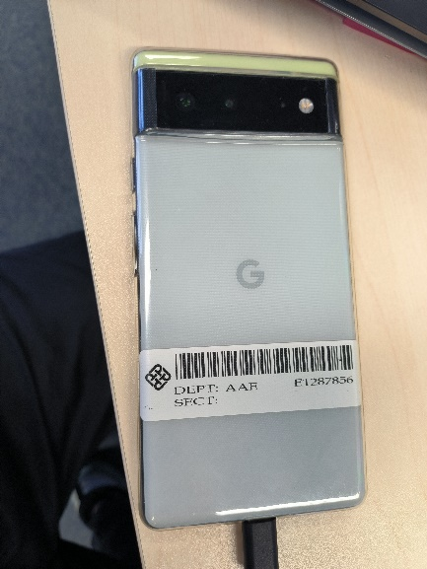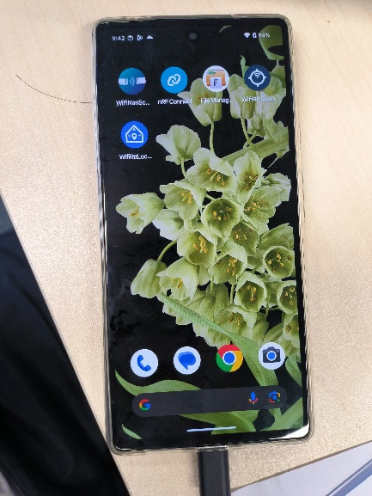

Fig 24: Illustration of an Andoriod smartphone.

**4.2 Data collection with smartphone receiver**

See the video: <https://www.bilibili.com/video/BV1qDsYe5EQA/>

**4.2.1 Collect data**

**Step 1:** Open the GnssLogger app in the smartphone, and click the start log, the GNSS data will be collected. When the data collection is complete, click stop.

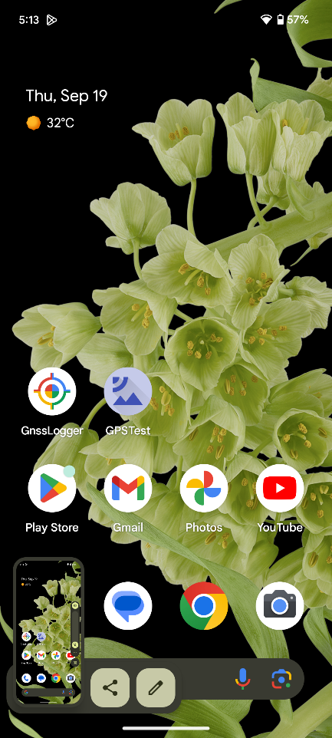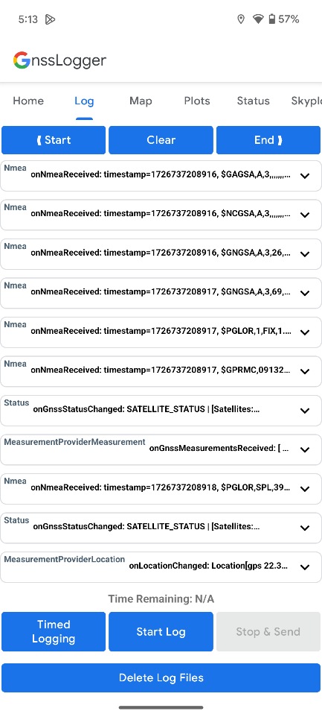



Fig 25: Illustration of GnssLogger app.

**4.2.2 Get the data from the smartphone**

**Step 2:** Use the USB to connect the smartphone to the computer.

**Step 3:** Enter the path \Pixel 6\Internal shared

storage\Android\data\com.google.android.apps.location.gps.gnsslogger\files\gnss_log\

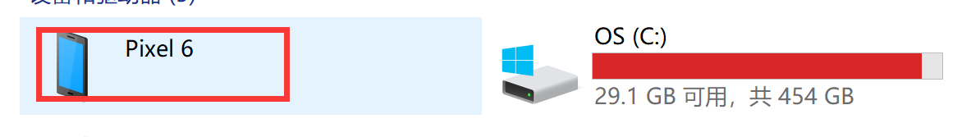

Fig 26: Illustration of path Pixel 6.

**Step 4:** Copy the corresponding data to the matlab folder according to the file time, which includes “.24o”, “.nmea”, “.txt” file

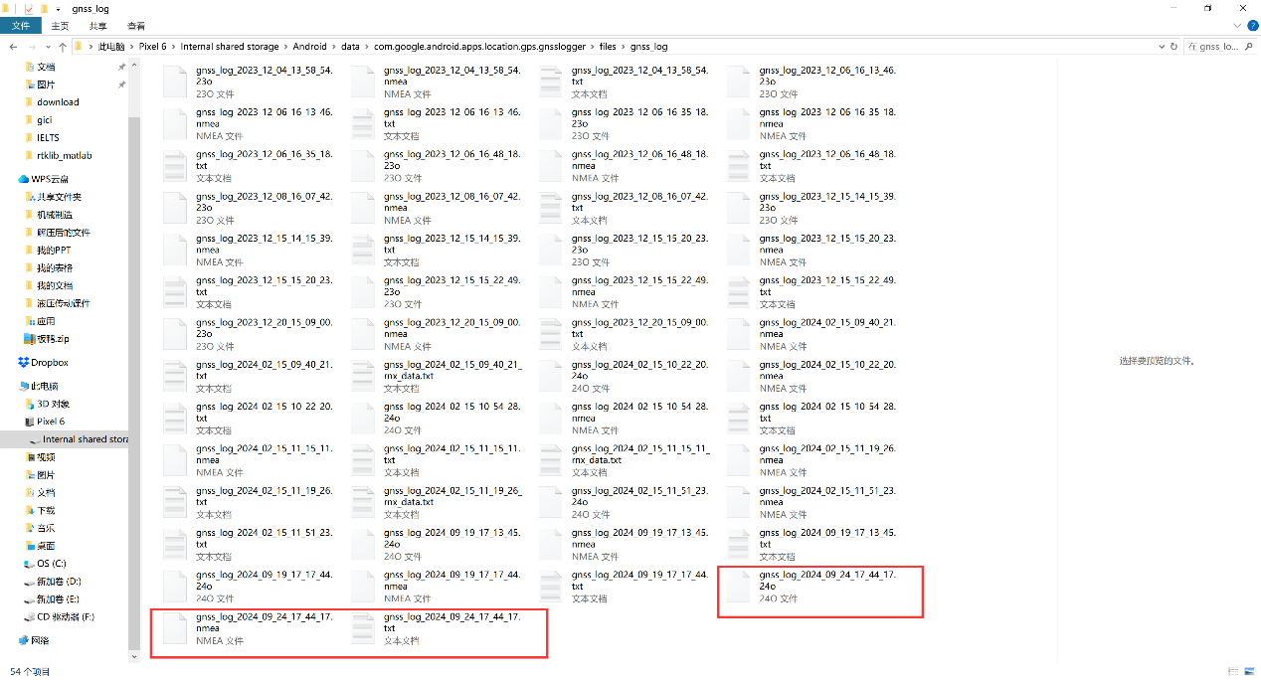

Fig 27: Illustration of “.24o”, “.nmea”, “.txt” file in computer.

**4.3 Data analysis with Sing positioning**

**4.3.1 Download the navigation file in the** [**Geodetic Survey of Hong Kong**](https://www.geodetic.gov.hk/en/rinex/downv.aspx)**.**

**Step 5:** Click the HKSC

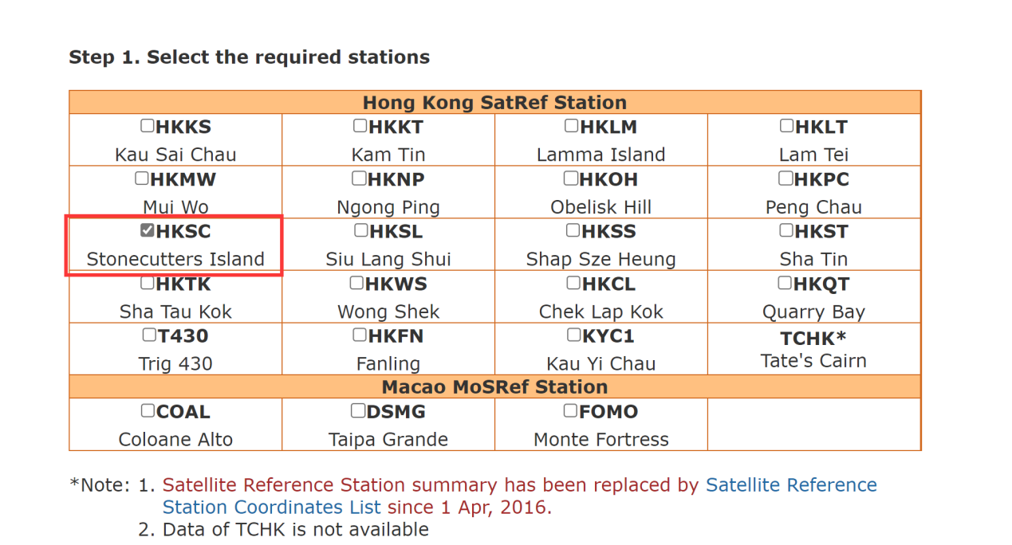

Fig 28: Illustration of web downloading navigation file: step 1.

**Step 6:** Select 1 hour and RINEX 3.02 format.

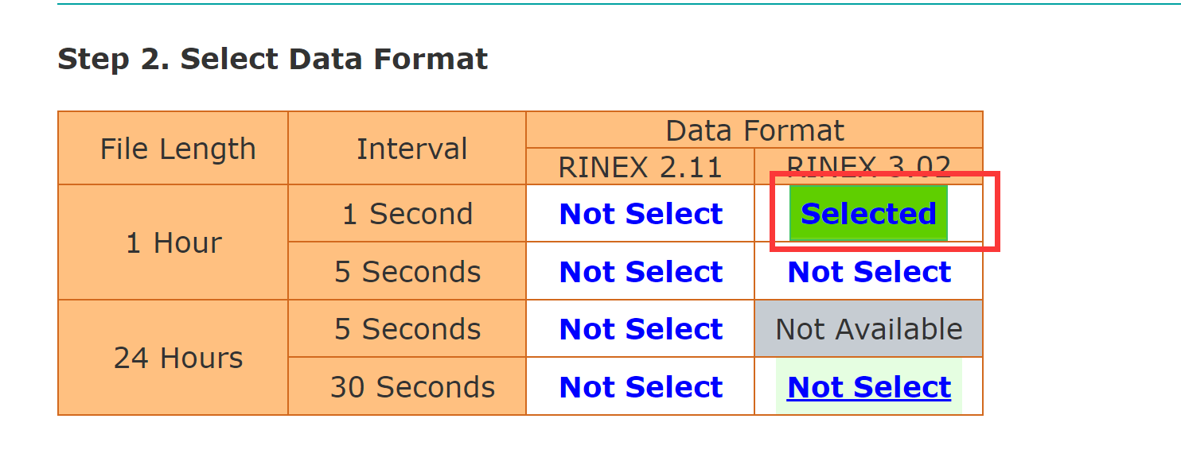

Fig 28: Illustration of dweb ownloading navigation file: step 2.

**Step 7:** Choose the time form the .24o file (which is got by step 2, use the vscode sofeware)

2024 09 19 09 14 (time:2024/09/19 09:14)

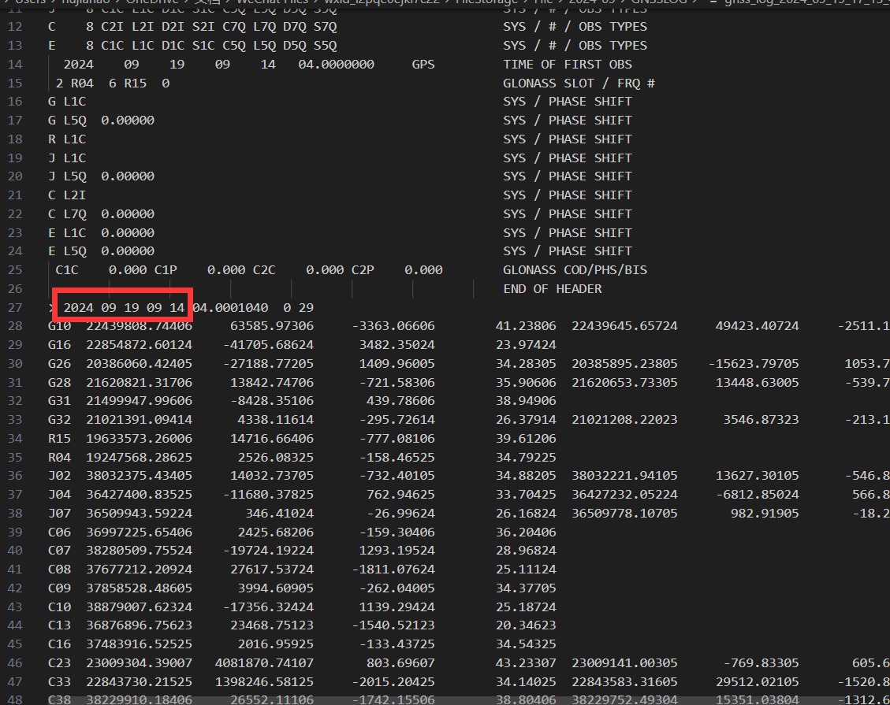

Fig 28: Illustration of .24o file in computer.

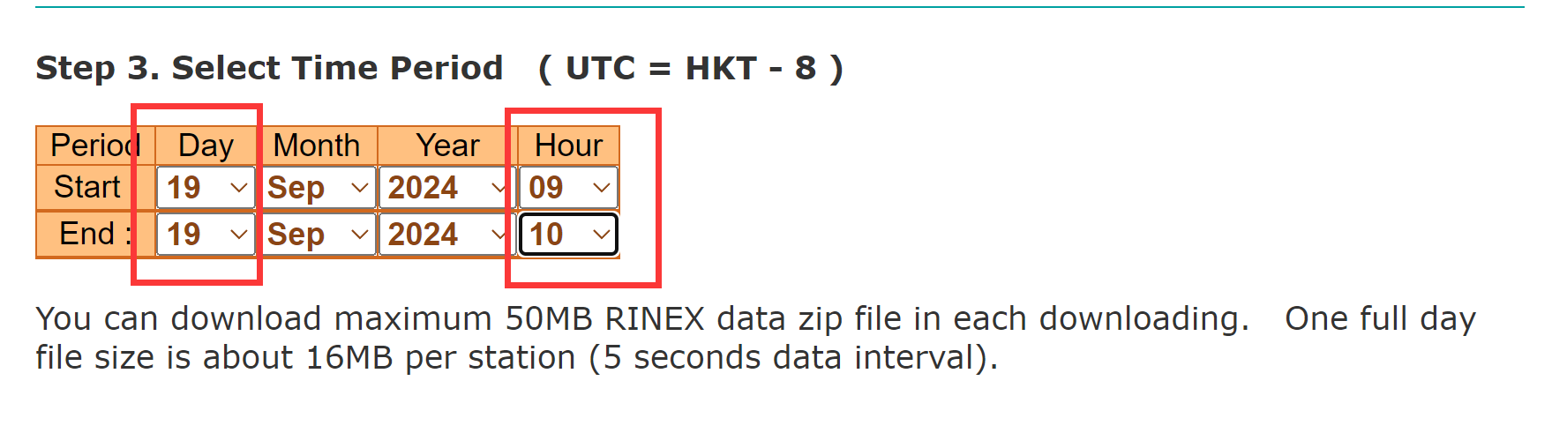

Fig 29: Illustration of web downloading navigation file: step 3.

**Step 8:** Click the submit selection

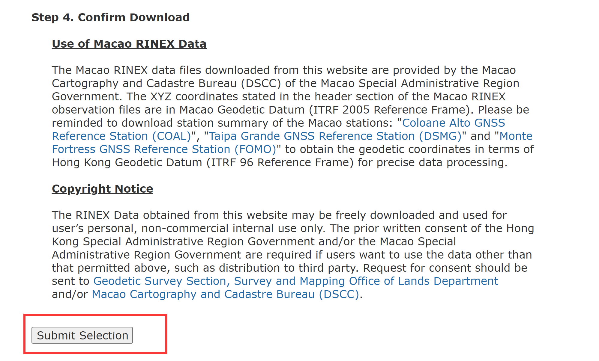

Fig 30: Illustration of web downloading navigation file: step 4.

**Step 8:** Click the download button.

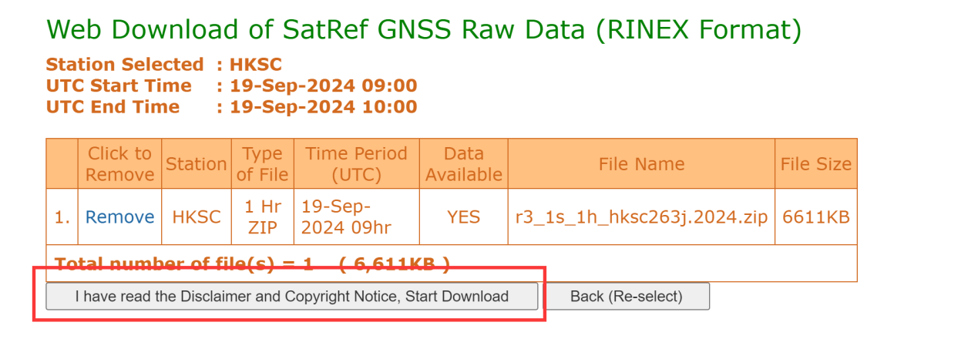

Fig 31: Illustration of web downloading navigation file: dowload.

**Step 9:** Extract the file and click the script.

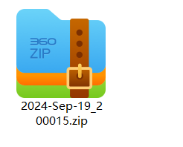

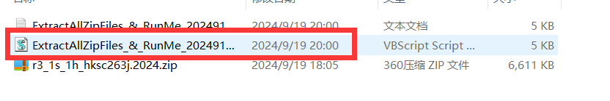

Fig 32: Illustration of the script.

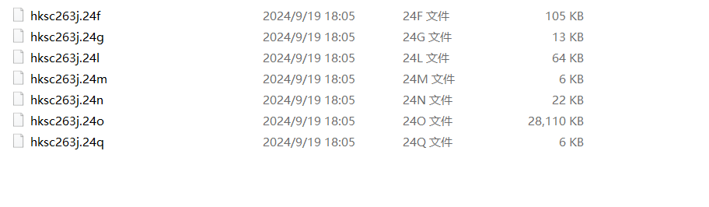

Fig 33: Files in output folder.

**Step 10:** Move all files of the output folder to the smartphone gnss .obs file (for example, E:\TA\rtklib_matlab\data\2024_0919)

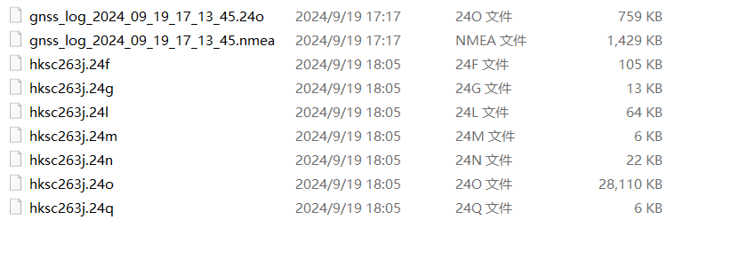

Fig 34: The organized file example.

**4.3.2 Obtain the ionospheric, tropospheric, pseudoranges, satellite clock bias and satellite positions.**

**Step 11:** Open the Matlab, run the generate_the_data.m, and get the ionospheric_delay.csv,

pseudoranges_meas.csv, satellite_clock_bias.csv, satellite_positions.csv, tropospheric_delay.csv files.

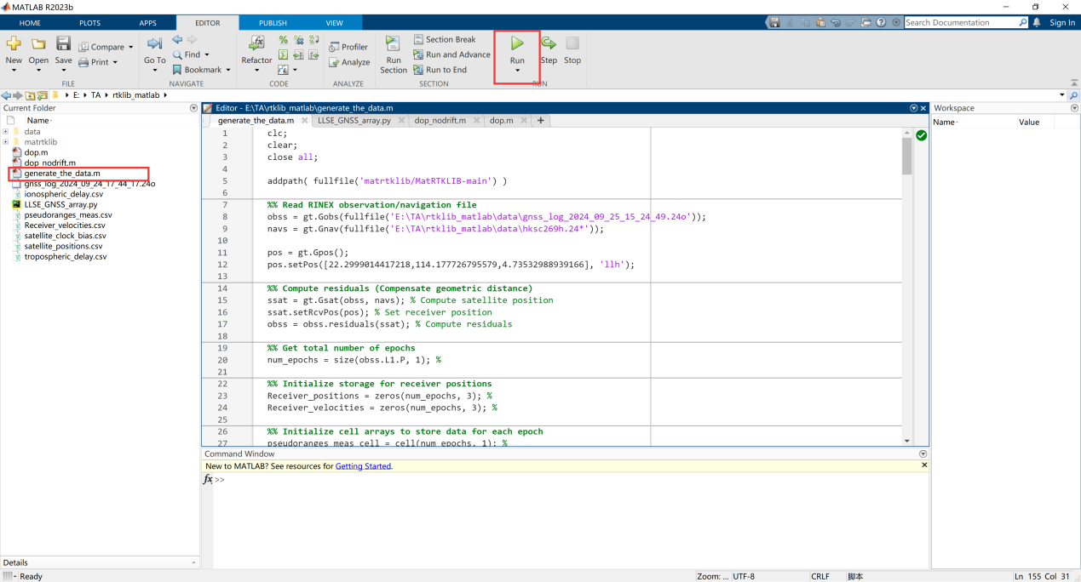

Fig 35: Illustration of MATLAB software in computer.

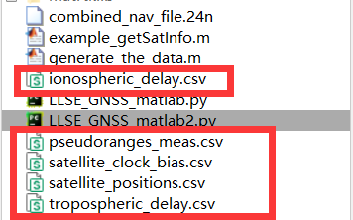

Fig 36: Illustration of the output files.

**4.3.3 Use the python program of least square method to deal with the data, and get the position.**

**Step 12:** Open the python program, “LLSE_GNSS_array.py” ,and change the file path, as shown below.

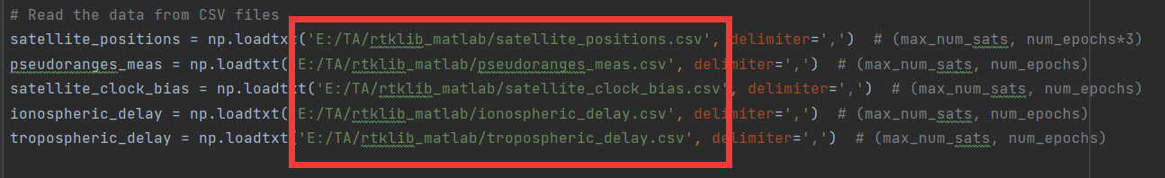

Fig 37: Illustration of the python program.

**Step 13:** Run the Python program and get two graphs, the first graph is the longitude and latitude coordinates, and the second is the ENU coordinates.

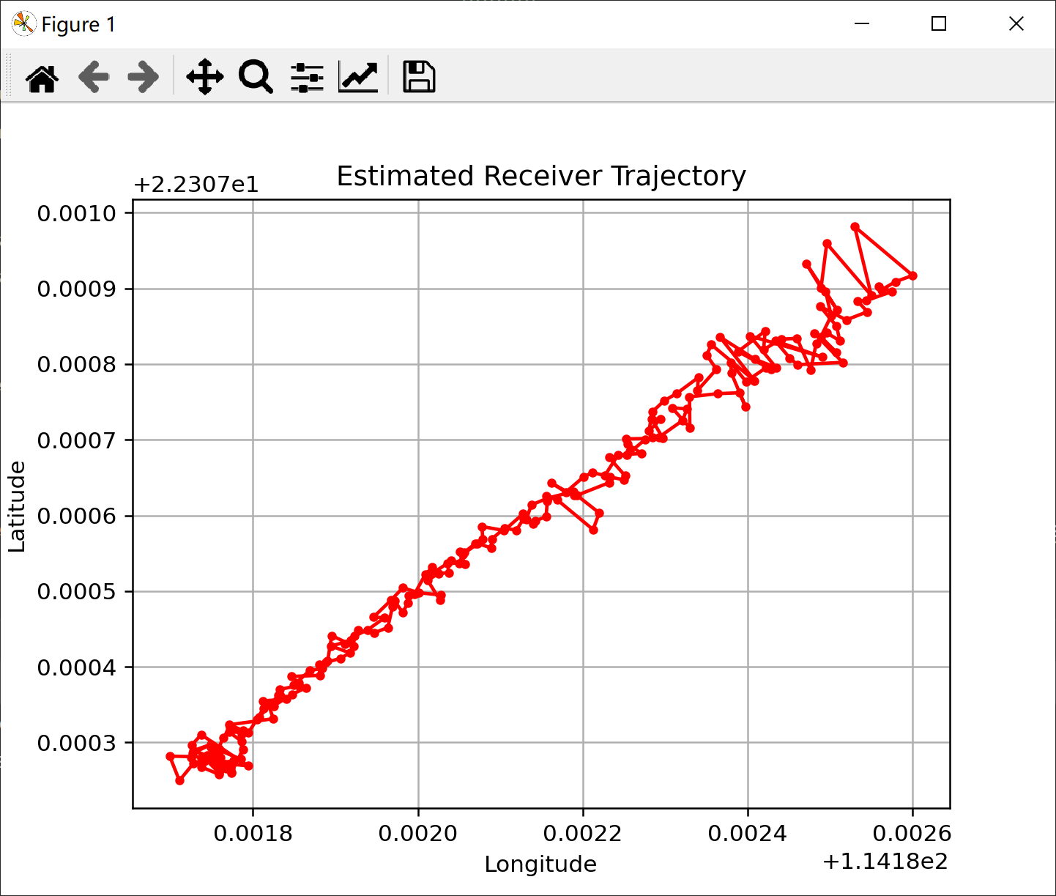

Fig 38: Estimated Receiver Trajectory in longitude and latitude coordinates.

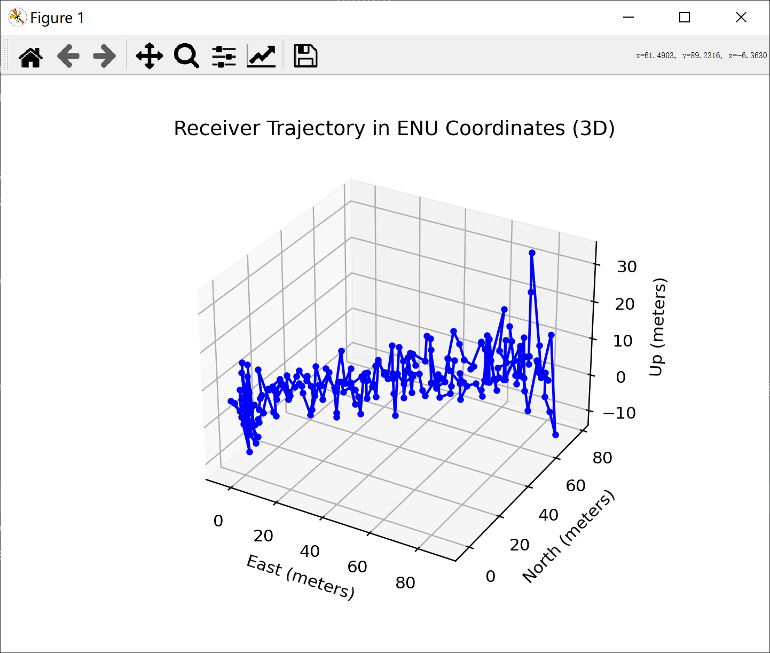

Fig 39: Estimated Receiver Trajectory in ENU coordinates.